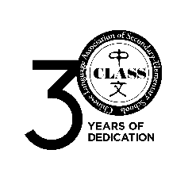 | 全美中小学中文教师协会  Chinese Language Association of Secondary-Elementary Schools
The Sixteenth National CLASS Essay Contest
May 2019

Student Pledge Form

Please have each essay contestant sign the following pledge.

Student Pledge:

I pledge that this essay is my original work, completed without my teacher’s or anyone else’s corrections or assistance.

- print name_______________________________________ sign name__________________________________
- print name_______________________________________ sign name__________________________________
- print name_______________________________________ sign name__________________________________
- print name_______________________________________ sign name__________________________________
- print name_______________________________________ sign name__________________________________
- print name_______________________________________ sign name__________________________________
- print name_______________________________________ sign name__________________________________
- print name_______________________________________ sign name__________________________________
- print name_______________________________________ sign name__________________________________
- print name_______________________________________ sign name__________________________________

